C:\Users\jstillman\AppData\Local\Microsoft\Windows\Temporary Internet Files\Content.IE5\ECCUI4GU\MC900280926[1].wmf

**HOMECOMING 2014: “Leader of the Pack”**

**Friday, October 17**

7:00 p.m. – **FOOTBALL GAME** – Hoxie Indians vs. Cheylin Cougars

**Saturday, October 18**

11:00 a.m. – **PARADE** on Main Street

11:30 p.m. – **LUNCH** at the 4H Building by the Boy Scouts

1:30 p.m. – **ALUMNI PROGRAM** in the Hoxie High School Auditorium

Honoring the **Class of 1964** and the **Class of 1989**

**ALUMNI RECEPTION** following in the HHS Library until 4:30

**SCHS/HHS Alumni Association hoxie_alumni@yahoo.com Find us on Facebook! August 2014**

**The Tomahawk**

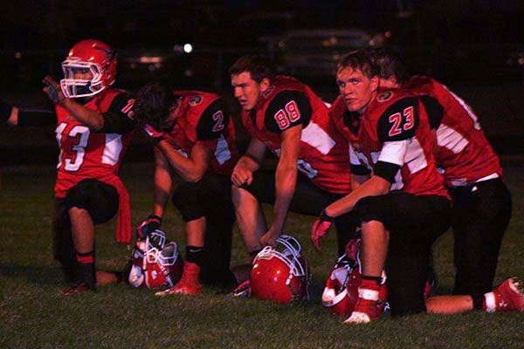

**HOXIE HIGH SCHOOL CLASS OF 2014**

**ALUMNI SCHOLARSHIP RECIPIENT:**

ALEX HAFFNER

*Alex is the daughter of*

*Greg Haffner ’82 and Heidi Haffner.*

*m (’81) Who.*

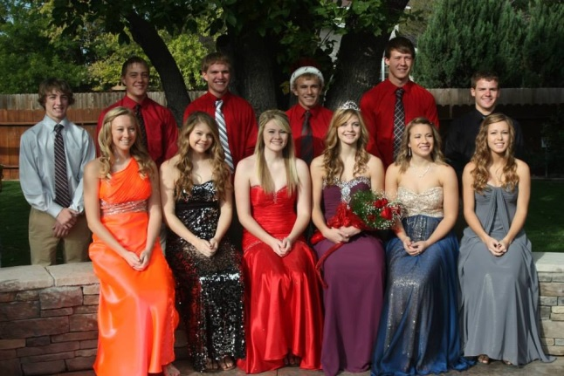

HHS Football team was victorious over the Ness City Eagles!

Class of 1963 celebrating their 50 year reunion.

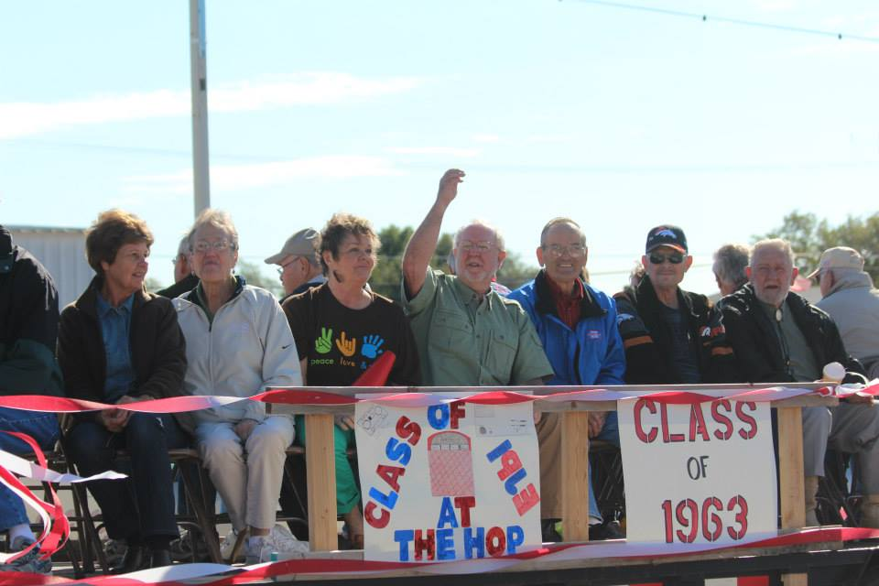

**SCHS/HHS ALUMNI ASSOCIATION BOARD**

Leslea Schamberger Oelke ’06, President Tami Cass Porsch ’91, Past President

DeeAnn Hockersmith Schamberger ’78, Vice President Jodee Carman Stillman ‘90, Treasurer

Misty Heim Stewart ’05, Secretary Harold Hartzog ‘79 Cyndie Taylor Aumiller ’86 Deanna Ochs Kennedy ’66 Kelly Campbell Meyer ‘97 Brandon Carver ‘03

Send your news or address changes to:

SCHS/HHS Alumni Association

P.O. Box 427, Hoxie, KS 67740

hoxie_alumni@yahoo.com

2013 Homecoming Royalty

**25 YEARS – CLASS OF 1989**

Bonnie (Timmons) Augustine

Andy Baalman

Greg Babcock

Jackie (Mullins) Baldwin

D’Ann (Otter) Basart

David Bieker

Alice (Meier) Brookshire

Nathan Brookshire

Bryan Bruggeman

Colette (Schlick) Dryden

Melissa (McMillan) Durant

Jessica (Ostmeyer) Eland

Brice Feldt

Sam Hale

Nicola Heskett

Frank Hill

Malia (Mense) Jarrett

Wayne Juenemann

Marvin Kaus

Scott Kennedy

Corina Knoll

Amy (Carder) Kroetch

Brad Kruse

Glenn Mader

Mike Mader

Christy (Ochs) Meitler

Jodi (Thummel) Morgan

Shane Ochs

Karen (McCormick) O’Neal

Rex Ostmeyer

Valarie (Ashbaugh) Patrick

Jennifer (Cressler) Phillips

Steve Reitcheck

Jennifer Reitcheck

Bob Schaffer

Bernie Schieferecke

Michelle (Tice) Slipke

Sara Spurgeon

Ronda Stark

Landee (Wade) Thyfault

Todd Tonkin

Alan Ward

Josie (Rodriguez) Weis

Nick Zerr

» In Memoriam «

*Vera (Mowry) Morgan, ‘34*

*Maxine McClelland, ‘40*

*Phyllis (Vickers) McClelland, ‘41*

*Frank Karnes, ‘46*

*Bill Samples, ‘50*

*Victor ‘Vic’ Karnes, ‘54*

*Raymond Bange, ‘55*

*Janice (Fromme) Brown, ‘61*

*Jim Heim, ‘62*

*Polly Stallings, ‘81*

*Russell Pope, ‘83*

**50 YEARS – CLASS OF 1964**

Frederick Andregg*

Velma (Babcock) Andregg

Edward Bange

Carla (Covalt) Chadwick

Anna Rose (Moellering) Delzeit

Janice (Mowry) Erickson

Tim Frazey

Lance Fromme

Robert Fromme

Robert Gallaway*

Carol (Ochs) Geerdes

Barbara (Leiker) Hansen

Anne (Cooper) Hunsecker

Diana (Popp) Jones

Pat (Washburn) Jones

Lynn Miller

Bill Neal*

Marilynn (Kennedy) Nemes

Larry Oren

Carolyn (Rumback) Owens

David Quakenbush

Joan (Schwarz) Rathbun

Barbara (Patmon) Ringer

Jon J. Rowlison

William Scott

Nancy Selbe

Linda (Selbe) Selbe-Watts

Rex Storer Sr.

Frank T. Summerson*

Roxie Shafer Truan

Gary Wade

Gordon Warren

Mary Ellen (Leopold) Welshhon

*An asterick* indicates the class member is deceased.*

**THE TOMAHAWK SCHS/HHS Alumni Association Newsletter August 2014 Page 2**